Rahul Harinath

Top Drivers by Miles

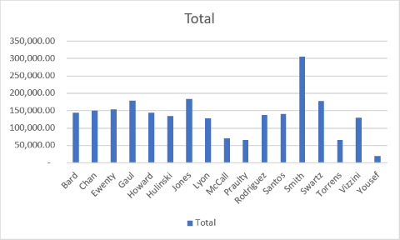

Scatter Chart for car inventory. Miles on each car

